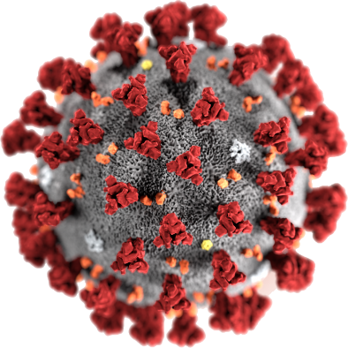

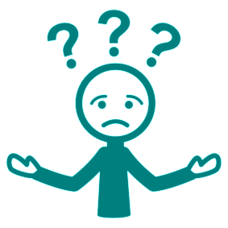

COVID - 19
What do I do?
20 March 2020

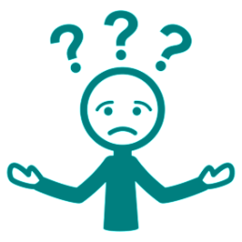
This fact sheet will tell you
- what to do. It will help you stay well
- how to stop you giving it to other people.

?
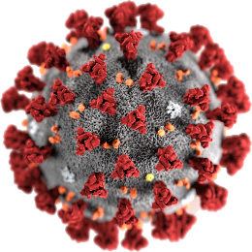
What is COVID - 19?

Read our fact sheet What is COVID - 19?

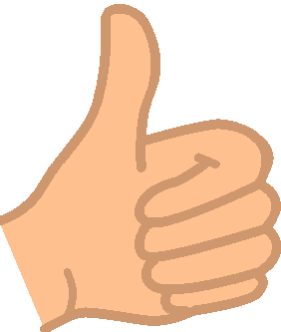
Keep your self well

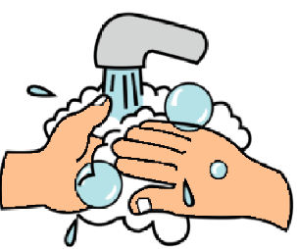
Wash your hands.
Use soap and water.

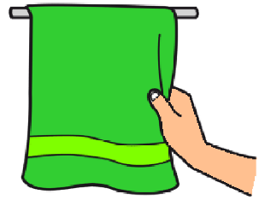
Dry your hands

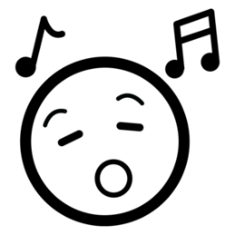
You need to wash your hands for a short time. Like sing Happy Birthday to you.
Wash your hands until you finish the song.

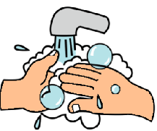
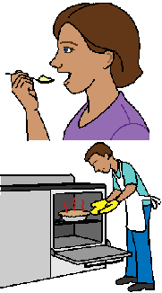
Wash your hands
- during the day
- before you eat
- before you touch food
- before you cook.

and

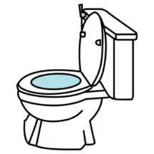
- after the toilet
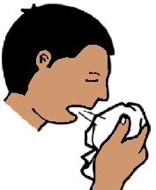
- after eating
- after you use a tissue.

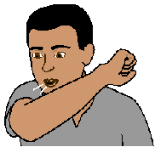
We do sometimes cough.
Cover your mouth when you cough.
Cough into your elbow like in this picture.

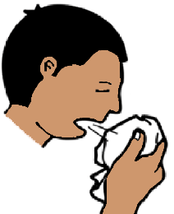
We do sometimes sneeze.
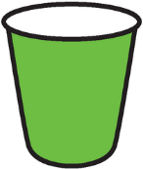
Use a tissue.
Put the tissue in the bin straight away.

And
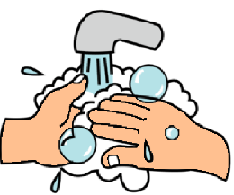
Wash your hands.

Keep away from other people.
Stand 3 big steps away from them.
This is called social distancing.

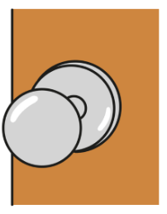
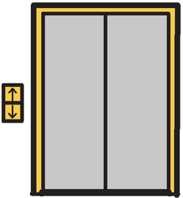
COVID - 19 may be on objects you use. Like
- door handles at public toilets
- buttons for lifts
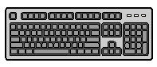
- tables
- computer keyboards.

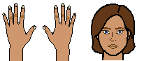
Do not put your hands near your mouth.

Wash your hands after you touch them.

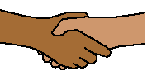
We meet people.
Do not shake hands.
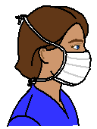
Masks
When you are well you do not need a mask.
Ask your doctor when you need to wear a mask.

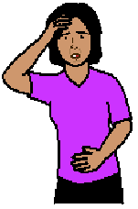
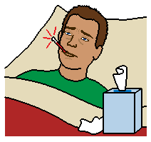
You may still get sick

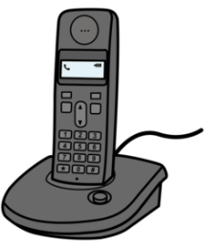
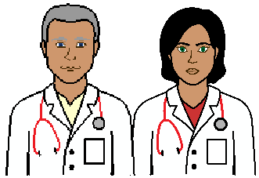

Ring your doctor before you go there.

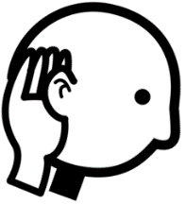
The doctor may come to you
or
Tell you to wait in a special place at their clinic.
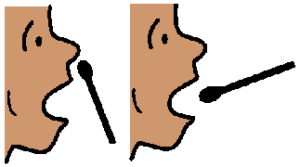
The doctor may do a test.
It will help the doctor know what to do.

When you are sick you
- may need to stay at home

or
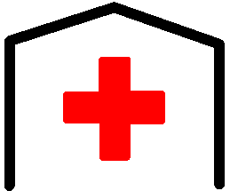
- go to hospital.
Your doctor will tell you. They will also tell you what to do if you get more sick.

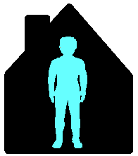
Your doctor tells you to stay at home.
This is called self-isolation.

Self-Isolation

You need to stay at home.

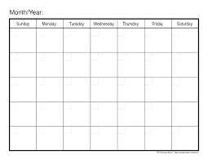

It will be for 2 weeks or more.

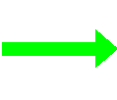
You must
- not go to work
- not go to friends homes
- not go to school
- not go to other activities. Like swimming.
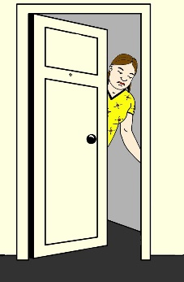
Only the people you live with must be at home.
You can not have visitors.

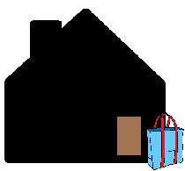
Ask other people to
- get some food for you.
- medicines.
- other things you must have.
They can leave it at your front door.

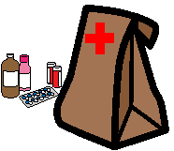
Many places may also drop things off for you. Like
- your chemist may do home delivery

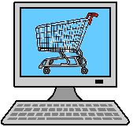
- order food online.
Get a mask.
You may have to go out.
You must wear your mask then.

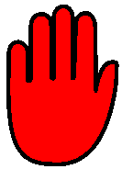
Your doctor will tell you when you can stop wearing your mask.

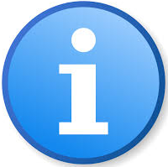
More information

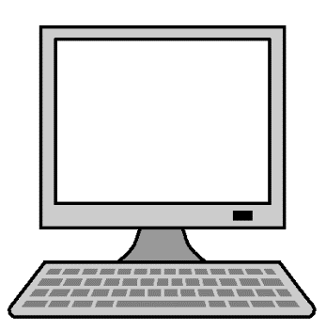
COVID - 19 information from the government.
www.health.gov.au

Call 1800 020 080.
You can call at
- any time
- any day.

Translations
Call 131 450

Images
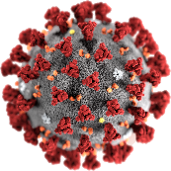
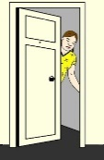
We have used images from
- Change People
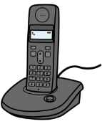
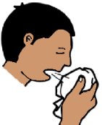
- Freepikpsd
- Mayer-Johnson
- Picto-Selector
- Clipart.

This fact sheet is based on
The Australian Government Health Department What you need to know. 17 03 2020.

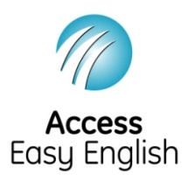
Access Easy English wrote the Easy English. March 2020.

