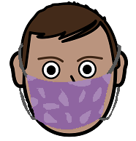

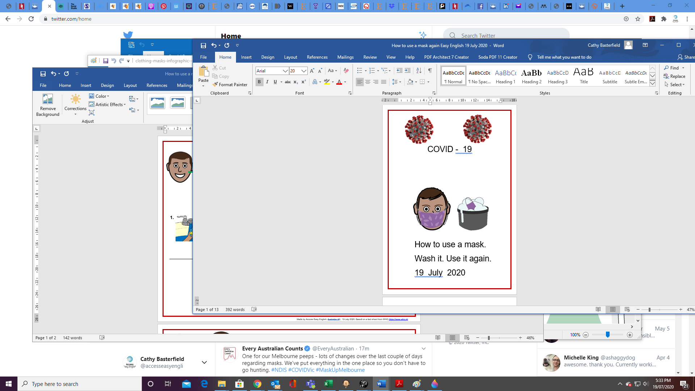Read the fact sheet

**How to put on a mask. How to put on a mask. You can use it again. You can use it again.**

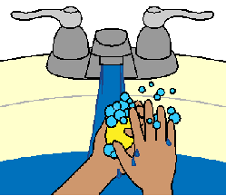

1. 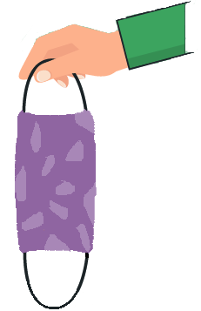 **2. 3.**

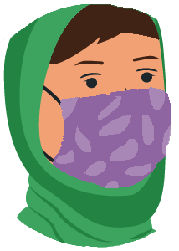

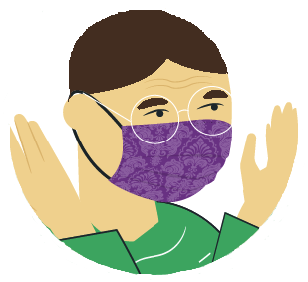

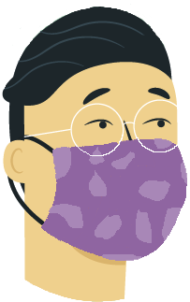

**4. 5.**

Made by Access Easy English. Australia A3. 21 July 2020. Based on a fact sheet from WHO [https://www.who.int](https://www.who.int/images/default-source/health-topics/coronavirus/masks-infographic---final-(web---rgb).png?sfvrsn=c67232f0_15)

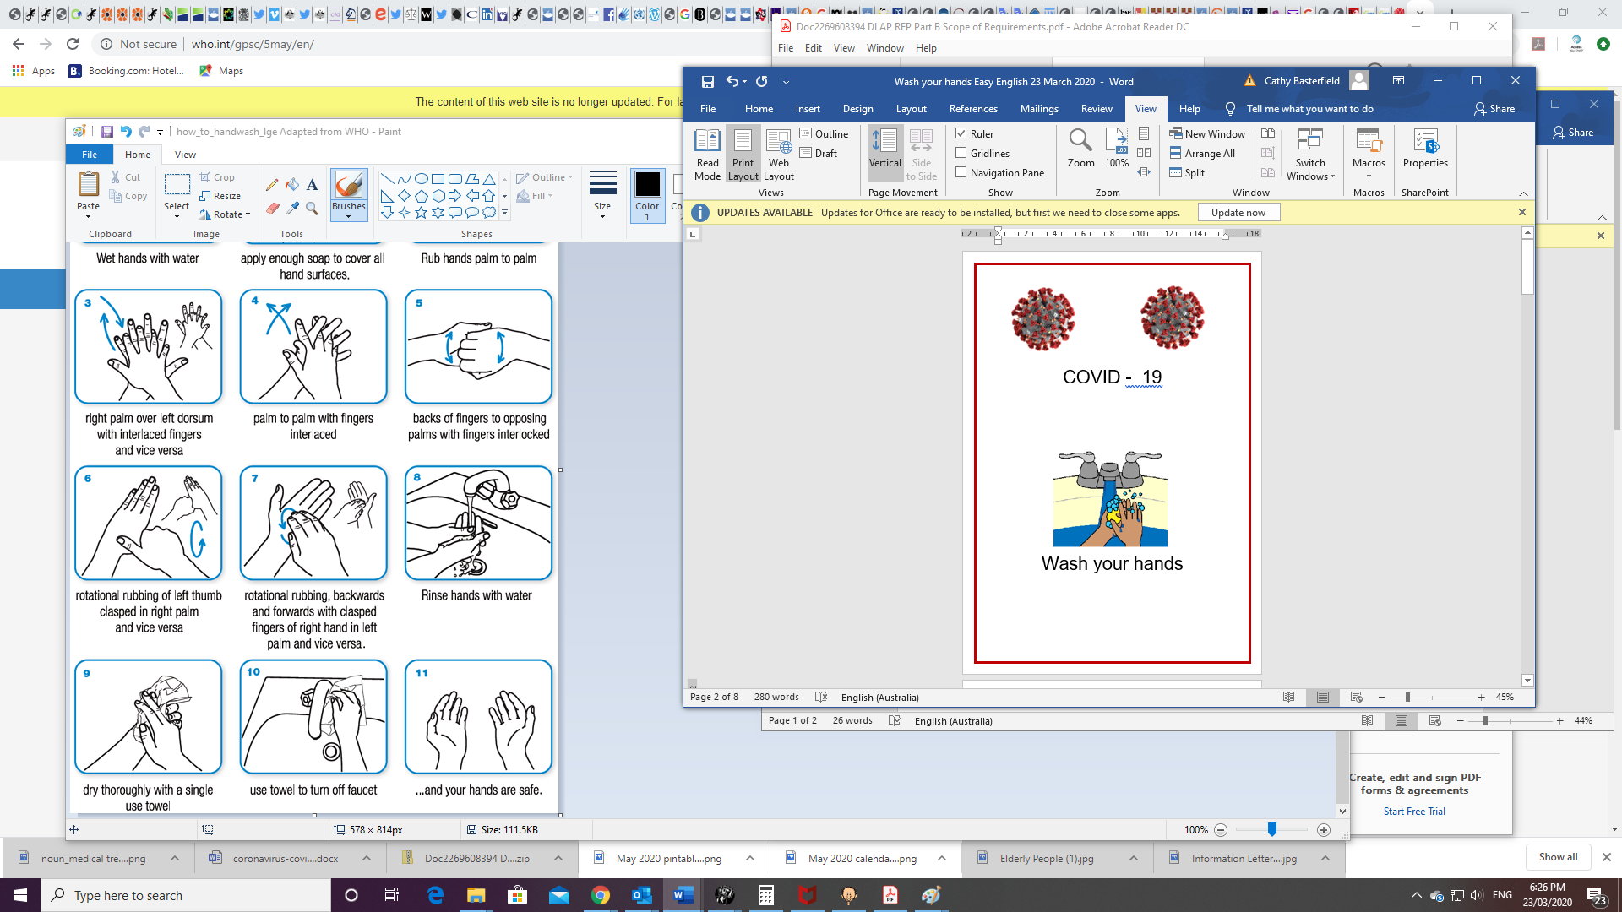



**How to take off a mask** Read the fact sheet

**Wash your hands**

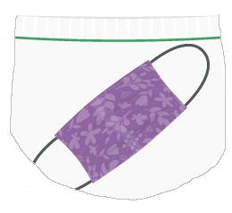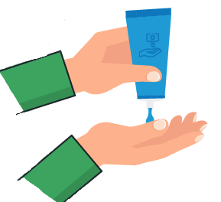

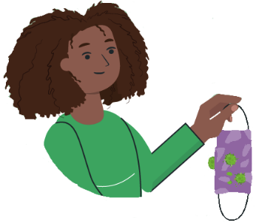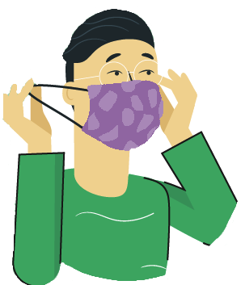**1. 2. 3. 4.**



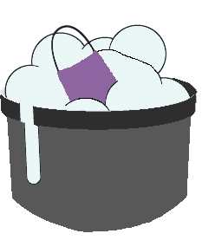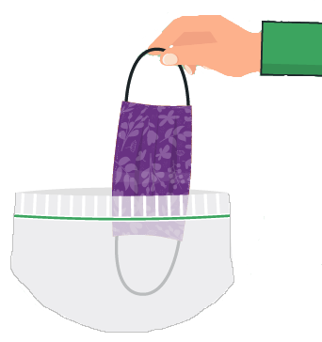**At home 5. 6. 7.**

Made by Access Easy English. Australia A3. 18 July 2020. Based on a fact sheet from WHO [https://www.who.int](https://www.who.int/images/default-source/health-topics/coronavirus/masks-infographic---final-(web---rgb).png?sfvrsn=c67232f0_15) How to wear a medical mask safely. Downloaded 17 July 2020.

Images from EasyOnTheI, Free, Mayer-Johnson, TheNounProject, WHO

Made by Access Easy English. Australia A3 poster 21 July 2020. Based on a fact sheet from WHO [https://www.who.int](https://www.who.int/images/default-source/health-topics/coronavirus/masks-infographic---final-(web---rgb).png?sfvrsn=c67232f0_15) How to wear a medical mask safely. Downloaded 17 July 2020.

Images from EasyOnTheI, Mayer-Johnson, WHO